**BBM233 Project**

**İbrahim Burak Tanrıkulu 21827852**

**State diagram:**

**Solution algorithm:**

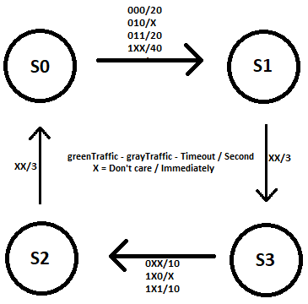

There are 3 inputs and 2 outputs in this controller.

First input (greenTraffic) means “there is congestion on main road”.

Second input (grayTraffic) means “there is congestion on side road”.

Third input (clock) is clock. I used both edges and changed clock per second.

First output (greenRoadLights) and Second output (grayRoadLights) are traffic lights that

[2] is “GO”, [1] is “ATTENTION”, [0] is “STOP”.

I used 4 states for that:

s0 (100) “GO” , s1 (110) “GO-ATTENTION” , s2 (011) “ATTENTION-STOP” , s3 (001) “STOP” .

I used an integer register (count) for counting elapsed seconds of states.

I used if-else statements for changing states.

Increased “count” every clock edge and checked “count”.

Created “Timeout” for preventing too long and too short states.

If count reaches right value: change state, reset count.

**Testbench Results:**

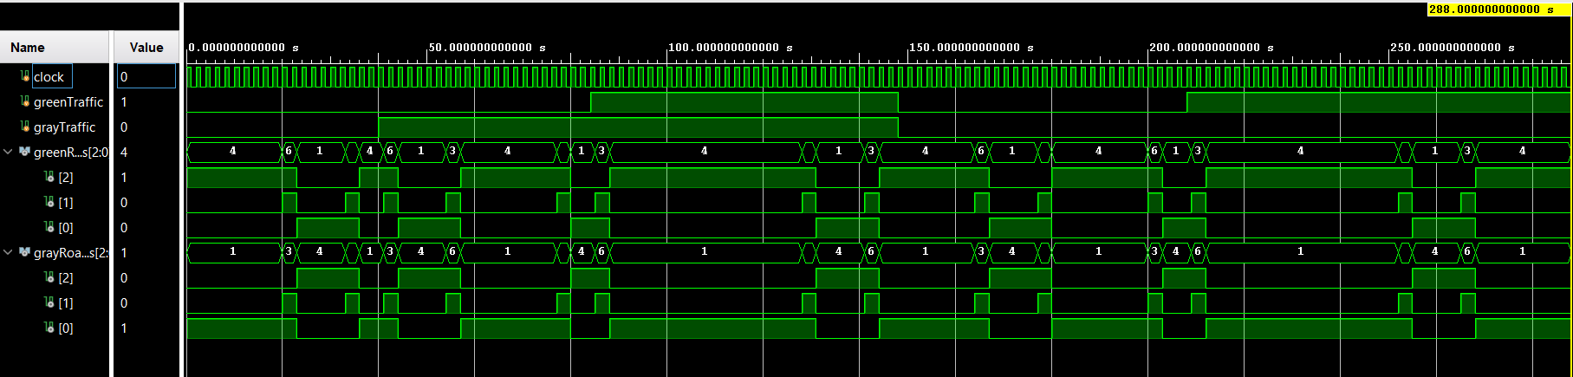

**Notes:**

In testbench, used 1000 ms instead of 1s. So in testbench I used like “#1000”.